Perform Data Quality Assessment, Duplicate Detection, Group-Wise Analysis, and Price Analysis Using Pandas
Data:
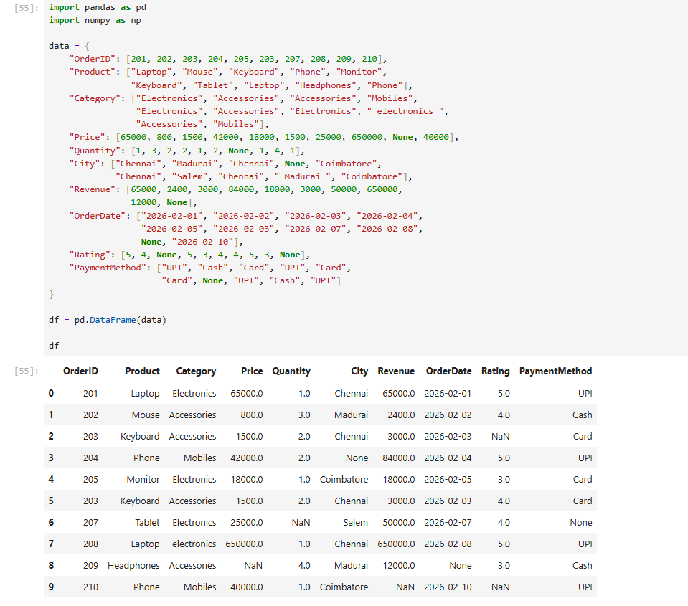
- To identify missing values in each column:
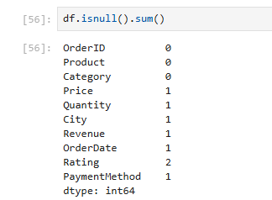

Possible causes:
- Customers or employees left fields blank.
- Data was lost during data import or system integration.
- Some transaction details were not captured correctly.
Solutions:
- Make essential fields mandatory during data entry.
- Validate incoming data before storing it.
- Use fillna() for suitable fields, such as filling missing ratings with the median.
- Use dropna() only when the missing information makes a record unusable and removing it is justified.

- To identify repeated orderIDs:
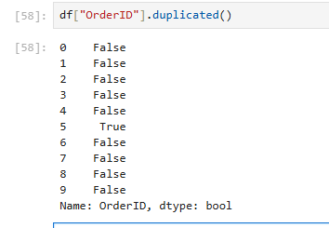
Possible causes:
- The same transaction was imported more than once.
- A customer submitted an order multiple times.
- The system retried a transaction without checking whether it already existed.
- An order legitimately contains multiple product line items.
Solutions:
- Compare repeated records with the original order or transaction logs.
- If they are genuine duplicates, remove only the confirmed duplicate records.
- If an order can contain multiple items, identify records using both OrderID and a line-item identifier.
- Add database constraints or idempotency checks to prevent duplicate transaction processing.

- To identify the highest priced product:
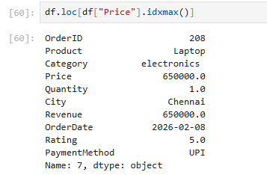
Possible causes:
- The product is genuinely premium or high-end.
- Supplier costs or market prices have increased.
- A data-entry mistake added an extra zero.
- The wrong product's price was associated with an order.
Solutions:
- Verify the price against the product SKU, invoice, and supplier records.
- Compare it with market prices and similar products.
- Apply price validation rules and flag unusually high prices for review.
- Do not automatically delete an unusually high value; it may be legitimate.

- Grouping revenue by city:
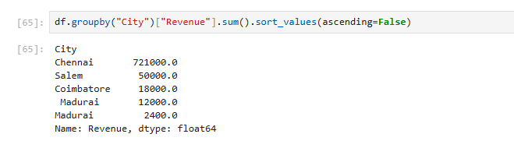

Possible causes:
- The product is genuinely premium or high-end.
- Supplier costs or market prices have increased.
- A data-entry mistake added an extra zero.
- The wrong product's price was associated with an order.
Solutions:
- Verify the price against the product SKU, invoice, and supplier records.
- Compare it with market prices and similar products.
- Apply price validation rules and flag unusually high prices for review.
- Do not automatically delete an unusually high value; it may be legitimate.

